# Lab 4-Linux Shell Scripting:

## Tasks

**Follow the instructions of your instructor and use the above concept of shell scripting complete the following.**

**Q1: Write a script to write and then read a file and view it on screen using the parameters and input from user**

**Code:**

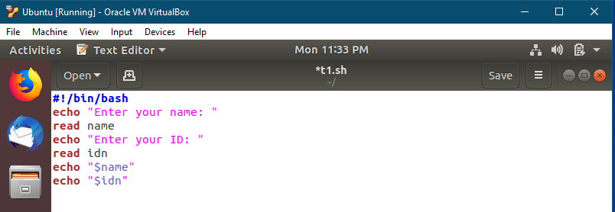

**Output:**

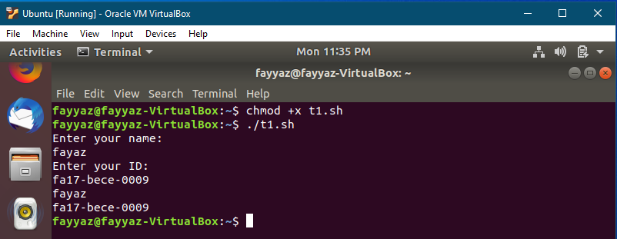

**Q2: Write 2 C program one prints “I love Operating System” and other prints “I love Linux”. Compile and Run both programs and print the output to two different files. After then combine both the files in one new file using a single command.**

**Code:**

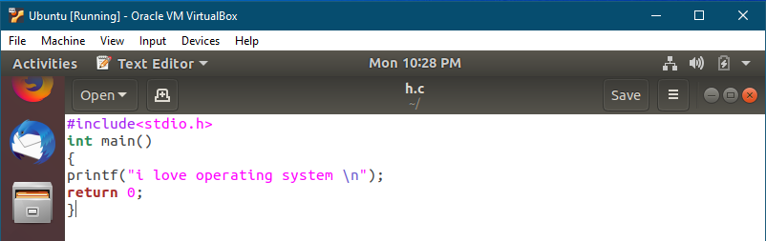

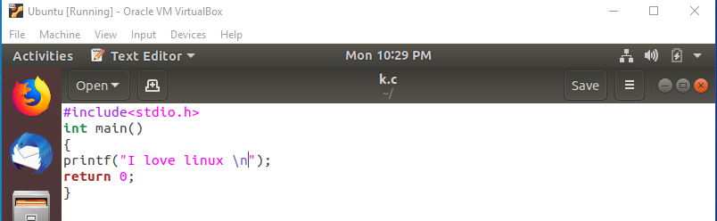

**Output:**

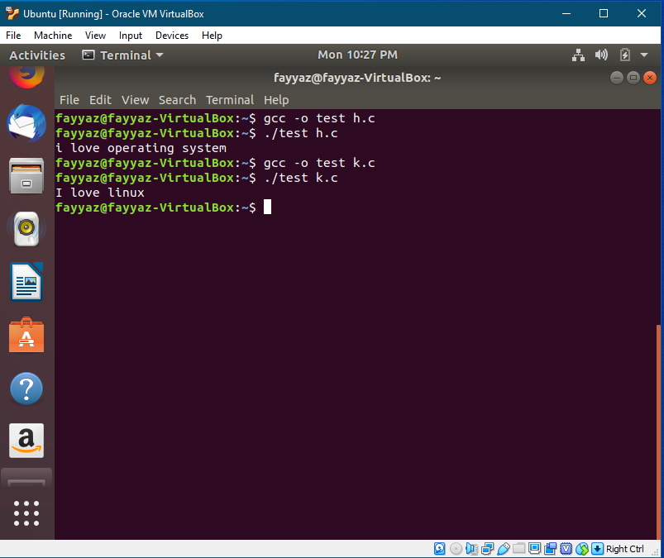

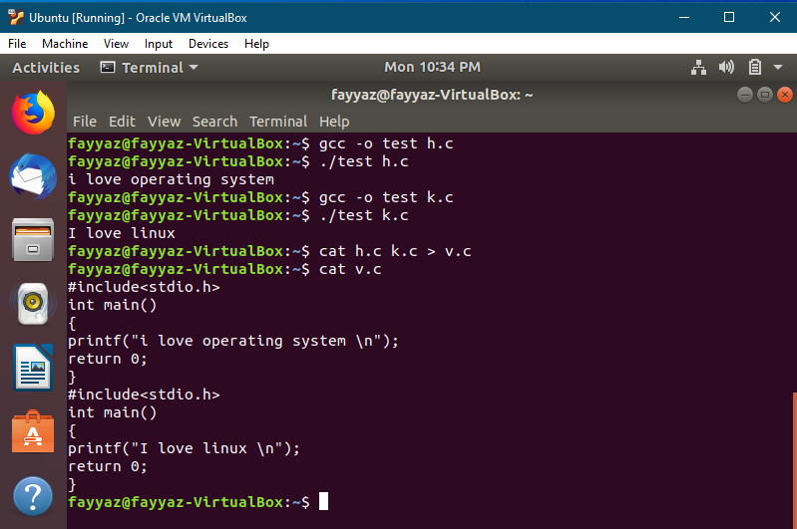

**Q3: Write scripts /commands / syntax to print a message “Welcome to the World of Shell Scripting”**

**Code:**

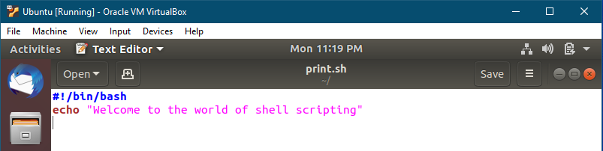

**Output:**

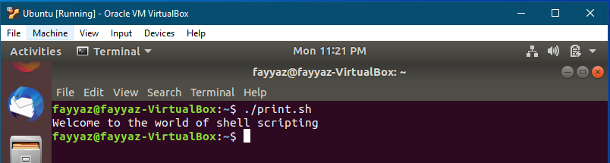

**Q4: Write scripts /commands / syntax to print user information who currently login, current date**

**and time**

**Code:**

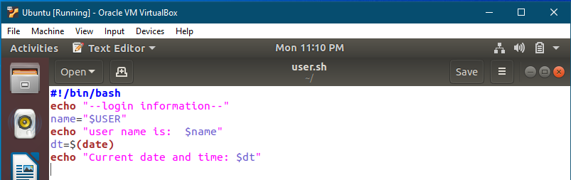

**Output:**

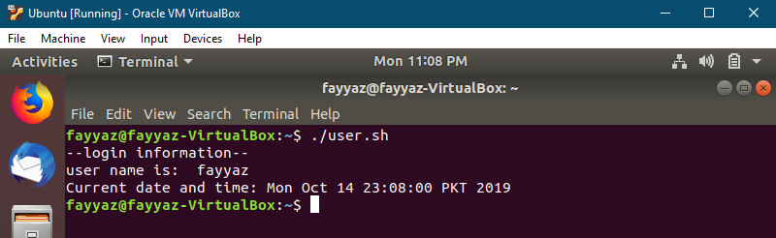

**Q5: Write scripts /commands / syntax to take input and print your name, degree program**

**information, batch No and course title**

**Code:**

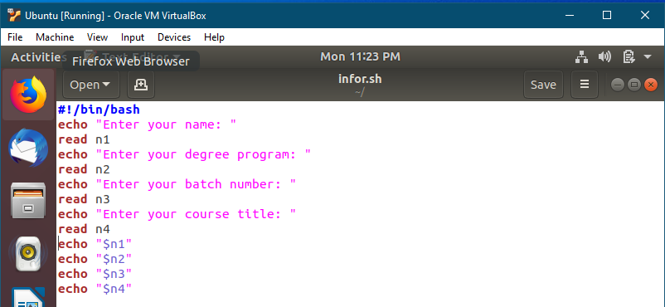

**Output:**

